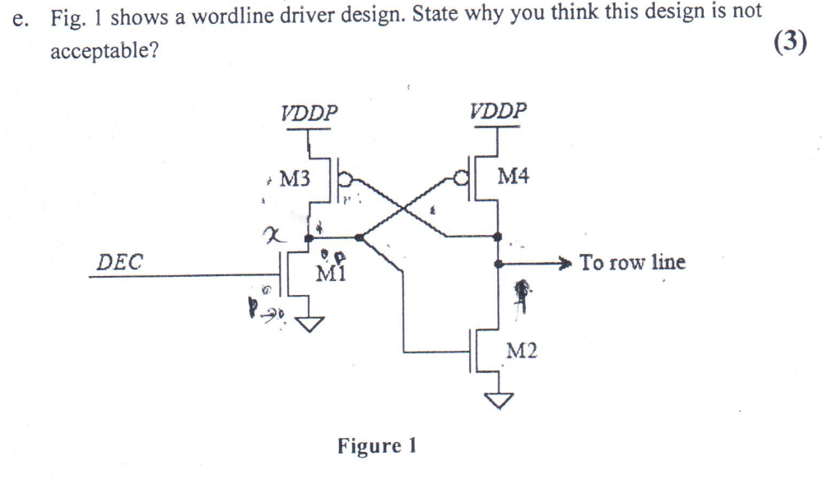
The drain of M1 and M3 will be in a floating state (labeled fnode
in the Spice example). This floating node will be known to be at its worse case when
you have just finished accessing the row because it will start off at ground. The node
is going to be somewhat unpredictable. Any dip in the word line voltage will turn on
M3 and start to charge the floating Node. This creates a condition where the Node
will increase upward until it reaches the critical voltage to turn the word line off fully.
Also the Node voltage moving upward at all will start this chain of events also. In
any case the word line will not turn off in a reasonable amount of time and the
unpredictability in the design is unacceptable.
Q2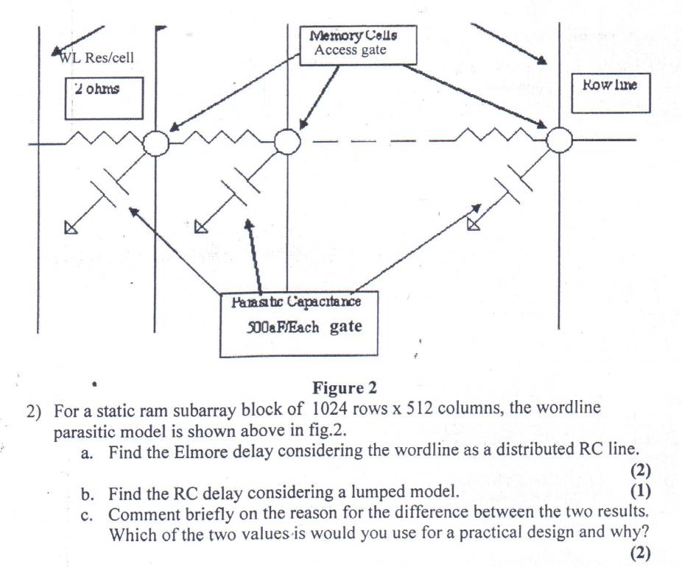

Given that there are 1024 column lines.
Resistance of the cell along the word line= 2 ohms/each cell
Capacitance w.r.t. ground=500aF/each cell
Elmore delay for a distributed RC line is given by
Time delay=
.35 x (number column lines)2 x (resistance/each cell)x(capacitance per each cell)
=0.35 x (1024)2 x (2 ohms) x (500aF)
=0.3668 ns
=366.8 ps.

For lumped we have to calculate ourselves.

For practical reasons, the worst case delay must be considered. The using total resistance and total capacitance, which are 2048 ohms and 512 pF,respectively.

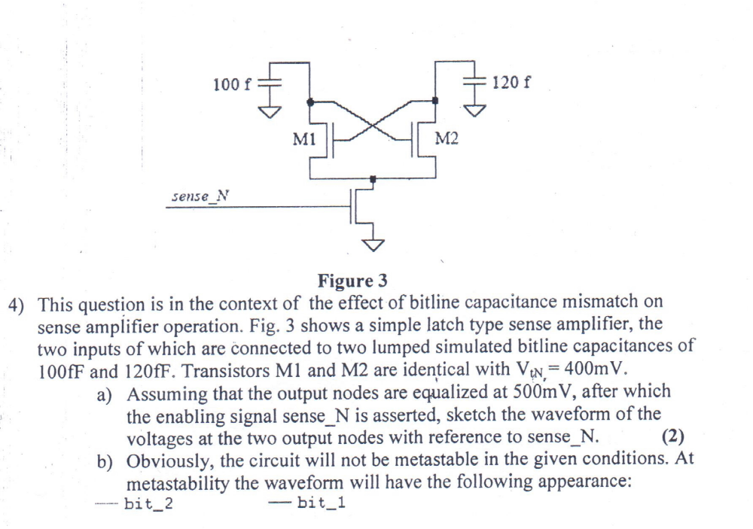

Assuming the capacitors are equilibrated to the same voltage of 0.5 V, when the sense_N signal
goes high both M1 and M2 transistors will be in the saturation region and an Ids current will
begin to flow in both transistors. We can approximate the behavior of the transistors as that of
resistors. We then can look at the circuit as two discharging RC circuits. The voltage equation for
a discharging RC circuit is
V(t) = Vie-t/RC. Eq 1
Where Vi is the initial voltage of the capacitor (.5V) and V(t) is the transient value of the voltage
at the drain of each transistor. Solving for t results in
T = -ln|V(t)/Vi| RC Eq 2
Looking at this equation we can see that the circuit with the larger capacitance will take longer to
discharge.
Now, looking back at the original circuit we can conclude that the 100f F capacitor will
discharge quicker, which in turn will shut off the M2 transistor. With the M2 transitor off, the
120 fF capacitor will stop discharging while the 100fF capacitor will continue to discharge to
ground.
To

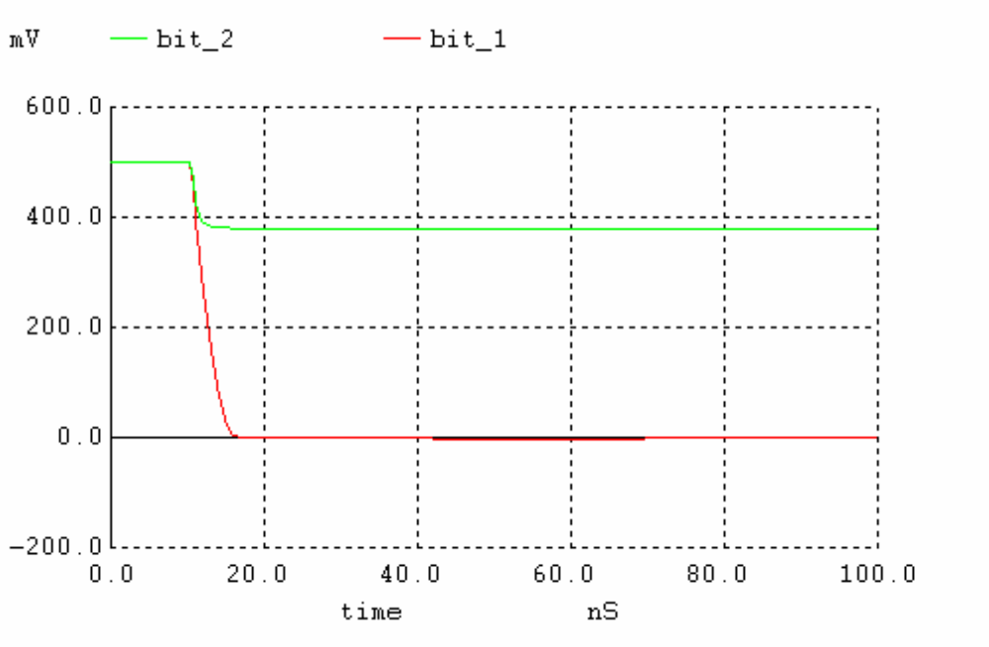

To calculate the initial capacitor voltage difference needed for metastability we will use the I-V
capacitor equation
I(t) = CΔv/Δt Eq 3
For the circuit to enter metastability, both transistors will move from strong-inversion down
through the triode region and eventually meet and stay at a certain VDS voltage.
Solving equation 3 for voltage and adding the initially capacitor voltages we get,
V1(t) = V1init –t(ID1/C1) Eq 4
V2(t) = V2init – t(ID2/C2) Eq 5
ID1 and ID2 can be taken from the first simulation. Looking at the plot, as the M1 transistor shuts
off ID1 goes from 20uA to 0. We will use 10uA for ID1 and ID2.
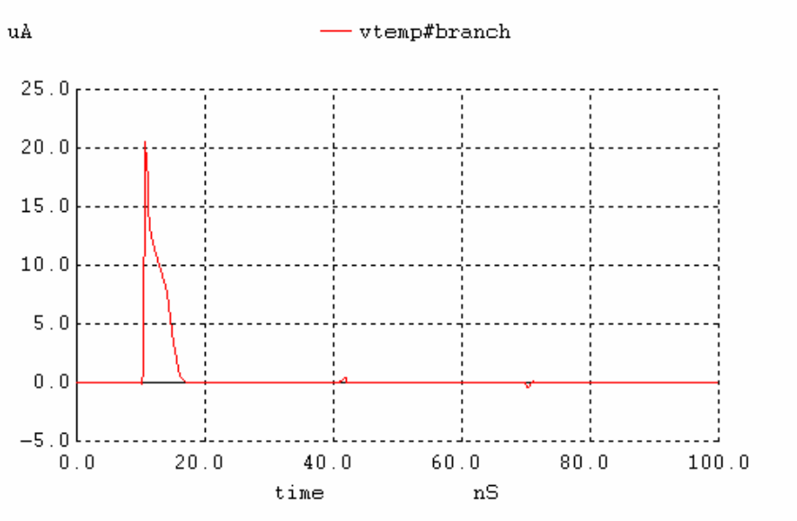
Lets assume that the voltage where V1DS and V2DS meet is above the threshold voltage , 400mV.
Now lets plug that into equation 5 and solve for t since we know that V2init is 0.5V.
T = -(V2 –V2init)(C2/ID2) = -(0.4 - 0.5)(120fF/10u) = 1.2ns
Now lets rearrange equation 4 and solve for V1init
V1init = V1(t) + t(ID1/C1) = 0.4 + (1.2n)(10u/100f) = .52V
Simulating with this initial voltage of capacitor one give us the plot below.
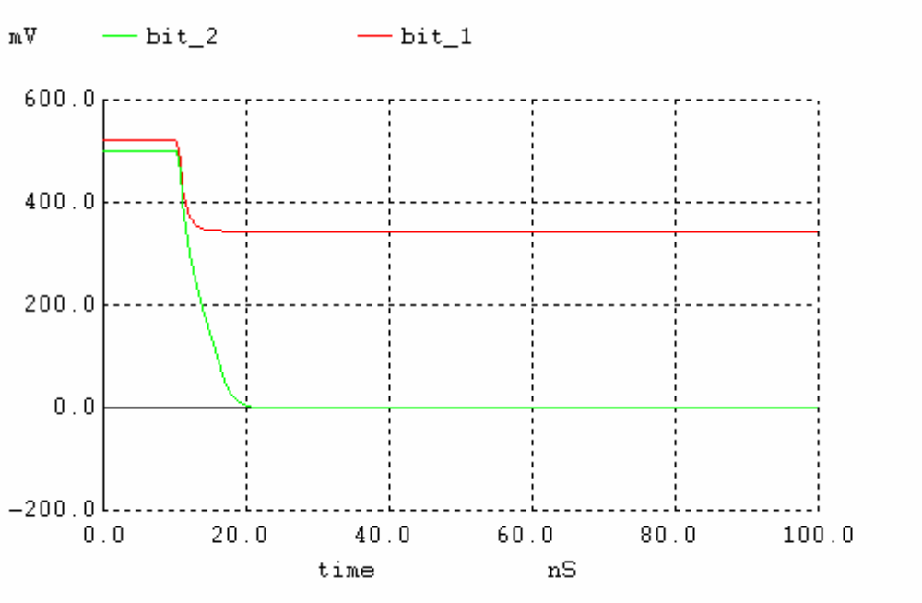

This is not metastability but gets us close, with a little trial and error of plugging numbers in
Spice and simulating we find that we get metastability when V1init = 0.5142. This is shown in
the plot below.

